# PRAKHAR VERMA

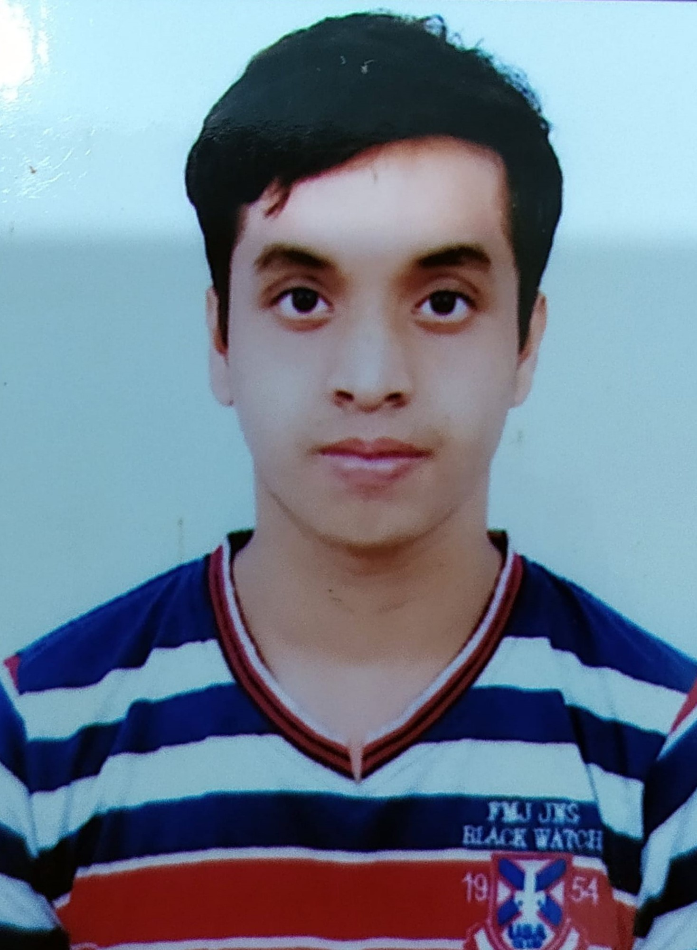Paste your professional picture here

Rana Pratap Nagar, Kanpur Nagar 208019

prakhar.verma_cs20@gla.ac.in +91 6386495450

# EDUCATION

**Bachelor of Technology (CSE), *GLA University, Mathura* 2020-2024**

**Intermediate, Maharana Pratap Education Centre, Kanpur 2018-2019 Highschool, Maharana Pratap Education Centre, Kanpur 2016- 2017**

**INTERNSHIP EXPERIENCE**

# GLA UNIVERSITY, Mathura June - August

# (Job oriented value added course)summer bootcamp

# • Reviewed and developed new user-facing feature, learned to maintain optimization of application with its speed and scalability.

# • It was a totally a independent internship, taught us about new technologies used all over the field.

# PROJECT

**HR Analytics**

Implemented NumPy and Panda libraries along with many machine learning classifier

**Machine Learning Project-Student Grade Prediction**

Implemented NumPy and Panda libraries.

**Responsive Portfolio**

Implemented html , Css and Javascript

# SKILLS

**Technical**

* C
* SQL
* Basic Python (for machine learning)
* Java(OOPS & DSA)
* Basic knowledge of web development

(HTML, CSS )

**Professional**

* Effective Analytical Skills
* Good in mathematics ,statistical approach and various data visualizing tools
* Ability to identify and solve problem
* Interpersonal skills
* Good presentation skills

# EXTRA/CO-CURRICULAR ACTIVITIES

* Attended workshop on Web Development
* Attended seminar of AI/ML

**DECLARATION**

I hereby declare that all the above-mentioned information is true and correct to the best of my knowledge.